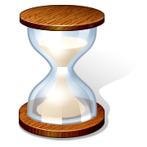
Advice About Conclusions
- Do not summarize! If your writing is clear, this would be redundant.
- Instead, connect the thesis to a larger issue—to the community, to yourself, to other works of literature. Look at big picture, what is universal about the story.
- Blend thesis, or main idea into this larger issue.
- “Bookend” the attention grabber from the introduction? (Just one option, but coming full circle is a very tidy way to finish a piece)

